**C PROGRAMMING ASSIGNMENT:**

**4**

DATE: 22.10.21

SUBMITTED BY:-

NAME: MUKTESH MISHRA

BRANCH: CSE

SECTION: B22

ROLL NO.: 21052258

**Program 1:** Write a program to find difference of two integers and two float

Code:

#include<stdio.h>

void main(int argc, char const *argv[])

{

    int a,b,c;

    float p,q,r;

    a=6;

    b=2;

    p=150.82;

    q=70.23;

    c=a-b;

    r=p-q;

    printf("The difference of two integers=%d\n",c);

    printf("The difference of two floats=%f",r);

    return 0;

}

Output:

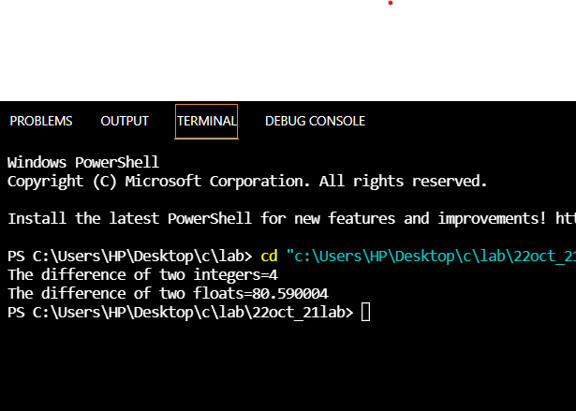

**Program 2:** Wrie a program to find sum of 2 float nos

Code:

#include<stdio.h>

//Sum of 2 float nos

float main()

{

    float a,b,c;

    a=5.9;

    b=8.3;

    c=a+b;

    printf("Sum is: %f",c);

    return 0;

}

Output:

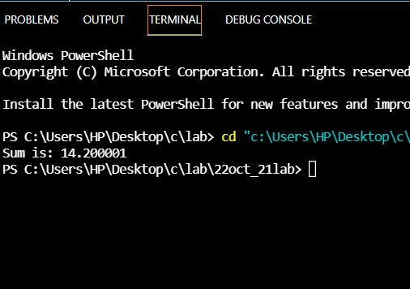

**Program 3:** Write a program to find product of two integers and two float

Code:

#include<stdio.h>

void main(int argc, char const *argv[])

{

    int a,b,c;

    float p,q,r;

    a=4;

    b=6;

    p=3.2;

    q=6.7;

    c=a*b;

    r=p*q;

    printf("The product of two integers=%d\n",c);

    printf("The product of two floats=%f",r);

}

Output:

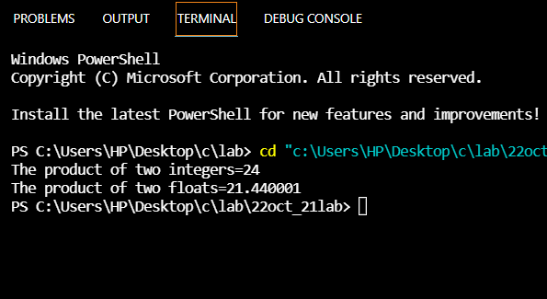

**Program 4:** Write a program to find difference of two integers and two float

Code:

#include<stdio.h>

void main(int argc, char const *argv[])

{

    int a,b,c;

    float p,q,r;

    a=6;

    b=2;

    p=150.82;

    q=70.23;

    c=a-b;

    r=p-q;

    printf("The difference of two integers=%d\n",c);

    printf("The difference of two floats=%f",r);

    return 0;

}

Output:

